Course: COSC457.101 – Database Management Systems

Instructor: Leon Bernard

Room: YR- 304

Quiz #1

Date: March 5, 2020

Student Name:

**Question 1 (***40 points***)**

Please draw an ERD from following description:

Draw an ERD for a small private airport database that is used to keep track of airplanes, their owners, airport employees, and pilots.

From the requirements for this database, the following information was collected: Each airplane has a registration number, is of a particular plane type, and is stored in a particular hangar. Each plane_type has a model number, a capacity, and a weight.

Each hangar has a number, a capacity, and a location. The database also keeps track of the owners of each plane and the employees who have maintained the plane.

Each relationship instance in owns relates an airplane to an owner and includes the purchase date. Each relationship instance in maintain relates to an employee to a service record service.

Each plane undergoes service many times; hence, it is related to a number of service records. A service record includes as attributes the date of maintenance Date, the number of hours spent on the work, and the type of work done.

The airplane registration number is used to identify a service record.

Each pilot has specific attributes license number and restrictions; each employee has specific attributes salary and shift. All person entities in the database have data kept on their social security number, name, address, and telephone number. For corporation entities, the data kept includes name, address, and telephone number.

The database also keeps track of the types of planes each pilot is authorized to fly and the types of planes each employee can do maintenance work on

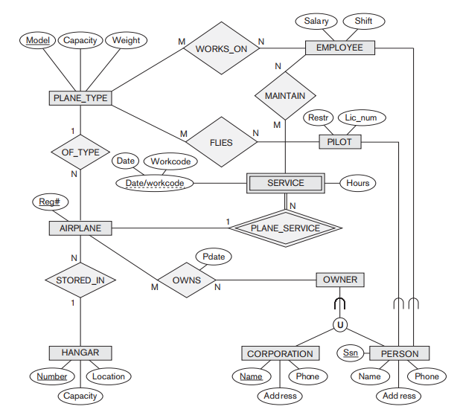

**Question 2 (40 points)**

Write appropriate SQL DDL statements for declaring the LIBRARY relational database schema of Figure 4.6. Specify the keys and referential triggered actions.

**Answers**

CREATE TABLE BOOK ( BookId CHAR(20) NOT NULL,

Title VARCHAR(30) NOT NULL,

PublisherName VARCHAR(20),

PRIMARY KEY (BookId),

FOREIGN KEY (PublisherName) REFERENCES PUBLISHER (Name) ON UPDATE CASCADE );

CREATE TABLE BOOK_AUTHORS ( BookId CHAR(20) NOT NULL,

AuthorName VARCHAR(30) NOT NULL,

PRIMARY KEY (BookId, AuthorName),

FOREIGN KEY (BookId) REFERENCES BOOK (BookId)

ON DELETE CASCADE ON UPDATE CASCADE );

CREATE TABLE PUBLISHER ( Name VARCHAR(20) NOT NULL,

Address VARCHAR(40) NOT NULL,

Phone CHAR(12),

PRIMARY KEY (Name) );

CREATE TABLE BOOK_COPIES ( BookId CHAR(20) NOT NULL,

BranchId INTEGER NOT NULL,

No_Of_Copies INTEGER NOT NULL,

PRIMARY KEY (BookId, BranchId),

FOREIGN KEY (BookId) REFERENCES BOOK (BookId)

ON DELETE CASCADE ON UPDATE CASCADE,

FOREIGN KEY (BranchId) REFERENCES BRANCH (BranchId)

ON DELETE CASCADE ON UPDATE CASCADE );

CREATE TABLE BORROWER ( CardNo INTEGER NOT NULL,

Name VARCHAR(30) NOT NULL,

Address VARCHAR(40) NOT NULL,

Phone CHAR(12),

PRIMARY KEY (CardNo) );

CREATE TABLE BOOK_LOANS ( CardNo INTEGER NOT NULL,

BookId CHAR(20) NOT NULL,

BranchId INTEGER NOT NULL,

DateOut DATE NOT NULL,

DueDate DATE NOT NULL,

PRIMARY KEY (CardNo, BookId, BranchId),

FOREIGN KEY (CardNo) REFERENCES BORROWER (CardNo)

ON DELETE CASCADE ON UPDATE CASCADE,

FOREIGN KEY (BranchId) REFERENCES LIBRARY_BRANCH (BranchId)

ON DELETE CASCADE ON UPDATE CASCADE,

FOREIGN KEY (BookId) REFERENCES BOOK (BookId)

ON DELETE CASCADE ON UPDATE CASCADE );

CREATE TABLE _BRANCH ( BranchId INTEGER NOT NULL,

BranchName VARCHAR(20) NOT NULL,

Address VARCHAR(40) NOT NULL,

PRIMARY KEY (BranchId) );